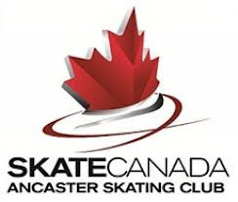 | ANCASTER SKATING CLUB  NOMINATION FORM  BOARD OF DIRECTORS 2023-2024  AGM – Monday, September 25th 2023  7:00pm – 8:00pm

The Ancaster Skating Club is run by a volunteer Board of Directors. The success of the Club is due to the enthusiasm and dedication put in by all our volunteers. The Board welcomes nominations for new members – please consider joining the ASC Board.
Please complete the shaded areas prior to returning form via email to:
macdonap@hhsc.ca by Saturday, September 23rd, 2023.

I, ________________________ wish to nominate
__________________________ to the Board of Directors of the Ancaster Skating Club for the 2023-2024 season.
Signature (Nominator) | Date
Signature (Nominee) | Date
Note: Nominations are submitted to the outgoing Board at the AGM, specific Executive roles for 2023-2024 are determined and voted on at the first Board meeting in October 2023. The Board consists of a minimum of 6 Directors and a maximum of 12 Directors.
ASC Board Executive includes:
- President
- Treasurer
- Secretary

